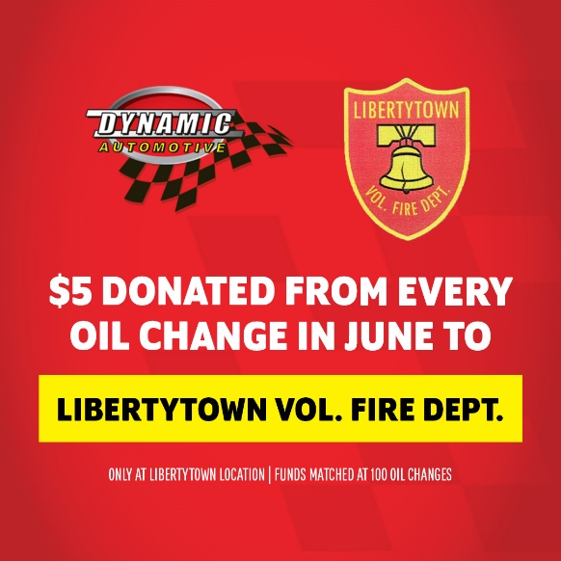

Join us in supporting first responders!

⛑ Dynamic Automotive - Libertytown will donate $5 to the Libertytown Volunteer Fire Department for every oil change we perform in June. But that’s not all! If we achieve 100 oil changes by the end of the month, we will match the funds raised to date! 🎉 Call us at 301-694-6250 to schedule your service.